***PROJECT WORK***

MOTHER DAIRY

Here's a comprehensive digital marketing plan for Mother Dairy:

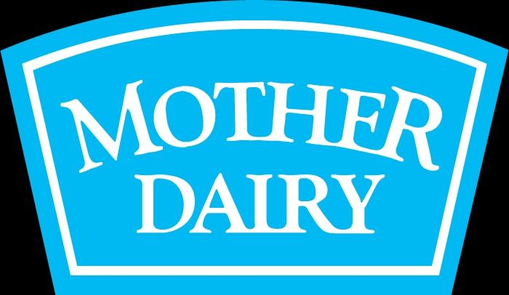

***Brand Marketing Strategy***

**1. Campaign Objective:** Increase brand awareness, drive sales, and establish Mother Dairy as a leader in the dairy industry.

**2. Target Audience:** Health-conscious individuals, families, and foodies.

**3. Unique Selling Proposition (USP**): Emphasize Mother Dairy's commitment to quality, freshness, and sustainability.

**4. Brand Positioning:** Position Mother Dairy as a trusted, customer-centric brand that prioritizes health, wellness, and community.

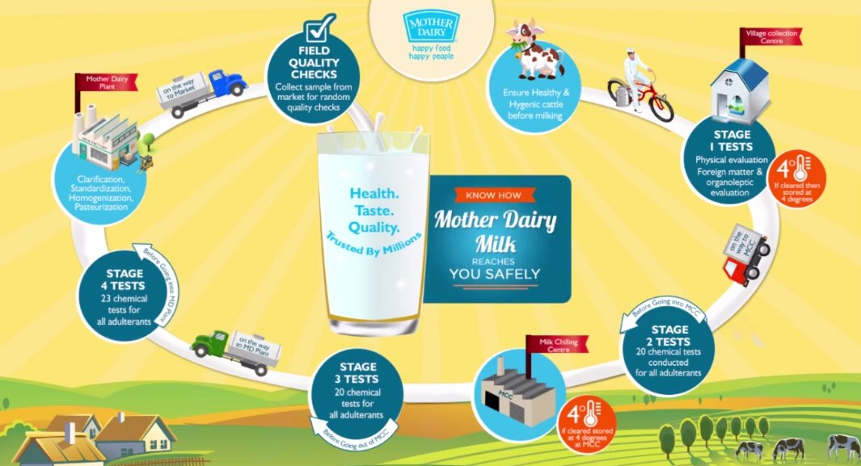

***Content Creation***

**1. Content Pillars:**

    - Health and wellness

    - Recipes and cooking tips

    - Sustainability and community

    - Product showcases and demos

**2. Content Types:**

    - Blog posts



- Social media posts (Facebook, Instagram, X, LinkedIn)



- Video content (YouTube, Instagram Reels)



- Influencer partnerships



**3. Content Calendar**: Plan and schedule content in advance using a content calendar.

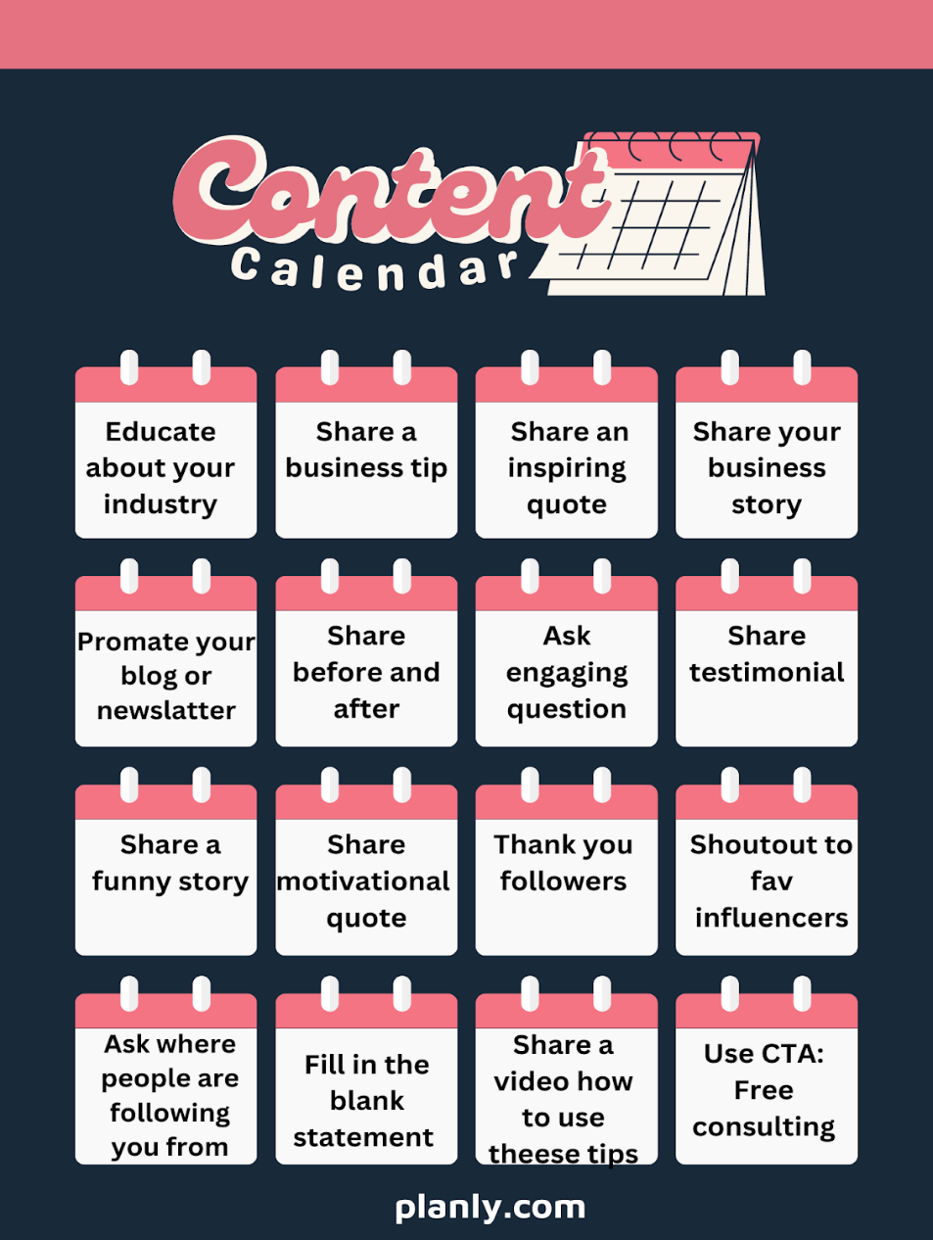

***SEO [Search Engine Optimization]* :**

**1. Keyword Research:** Conduct thorough keyword research to identify relevant terms such as "dairy products," "healthy recipes," and "sustainable farming."

**2. On-Page Optimization:** Optimize website pages, including:

    - Meta tags (title, description, keywords)

    - Header tags (H1, H2, H3)

    - Content optimization (keyword density, readability)

    - Image optimization (alt tags, descriptions)

**3. Technical SEO:** Ensure website technicalities, including:

    - Page speed optimization

    - Mobile-friendliness

    - SSL encryption

    - XML sitemap submission

**4. Link Building:** Develop a link building strategy, including:

    - Guest blogging

    - Resource pages

    - Partnerships and collaborations

    - Reviews and testimonials

***Social Media***



**1. Platform Strategy:** Establish a presence on Facebook, Instagram, Twitter, LinkedIn, and YouTube.

**2. Content Strategy:** Share a mix of promotional, educational, and engaging content.

**3. Influencer Partnerships:** Collaborate with influencers in the health, wellness, and food spaces.

**4. Paid Advertising:** Run targeted social media ads to drive website traffic and sales.

***Email Marketing***



**1. Email List Building:** Create a sign-up form on the website and offer incentives for subscription.

**2. Newsletter Content:** Share news, promotions, recipes, and health tips.

**3. Segmentation:** Segment the email list based on preferences, behavior, and demographics.

**4. Automation:** Set up automated email workflows for welcome emails, abandoned cart reminders, and birthday greetings.

***Measurement and Evaluation***

**1. Key Performance Indicators (KPIs):** Track website traffic, social media engagement, email open rates, conversion rates, and sales.

**2. Analytics Tools:** Use Google Analytics, social media insights, and email marketing metrics to monitor performance.

**3. Regular Reporting:** Schedule regular reporting to track progress, identify areas for improvement, and adjust the strategy accordingly.

By implementing this comprehensive digital marketing plan, Mother Dairy can increase brand awareness, drive sales, and establish itself as a leader in the dairy industry.

Here's a comprehensive analysis of the three activities:

***Brand Study***

**1. Brand Overview:** Mother Dairy is a leading dairy brand in India, offering a wide range of dairy products, including milk, cheese, butter, and ice cream.

**2. Brand Positioning:** Mother Dairy positions itself as a trusted, customer-centric brand that prioritizes quality, freshness, and sustainability.

**3. Brand Values:** The brand values quality, customer satisfaction, innovation, and social responsibility.

**4. Brand Personality:** Mother Dairy's brand personality is warm, friendly, and approachable, conveying a sense of trust and reliability.

**5. Unique Selling Proposition (USP):** Mother Dairy's USP is its commitment to quality, freshness, and sustainability, making it a preferred choice among consumers.

***Competitor Analysis***

**1. Competitor Identification**: Key competitors include Amul, Britannia, and Nestle.

**2. Competitor Strengths and Weaknesses:**

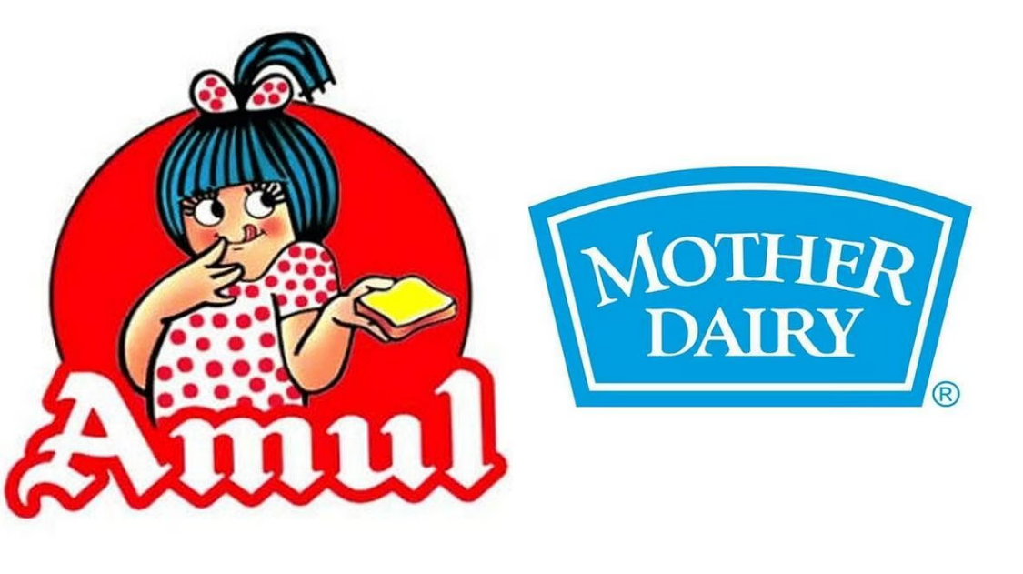

**- Amul:** Strong brand recognition, wide distribution network, and competitive pricing.

**Weaknesses:** Limited product portfolio and outdated branding.

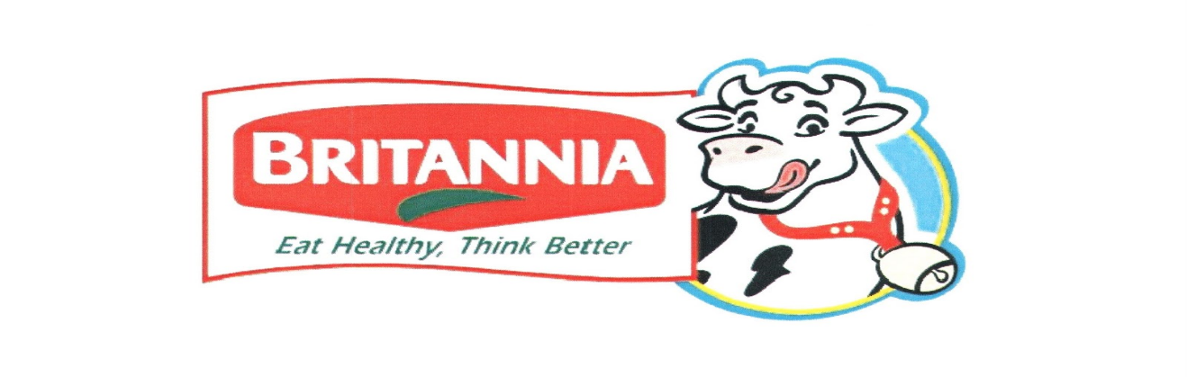

**- Britannia:** Strong brand reputation, wide range of products, and effective marketing strategies.

**Weaknesses:** High pricing and limited presence in rural areas.

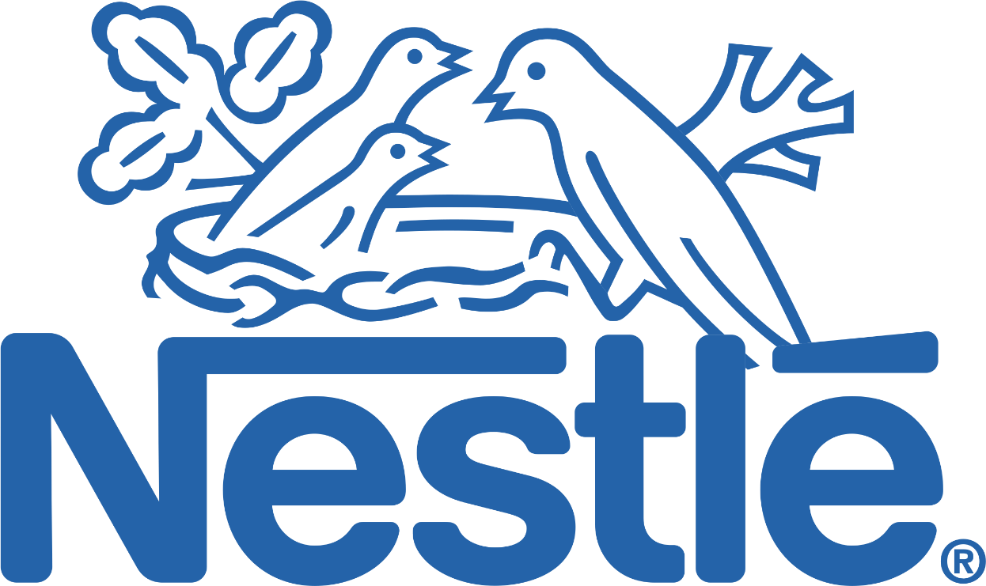

**- Nestle:** Strong global brand reputation, wide range of products, and effective marketing strategies.

**Weaknesses:** High pricing, limited presence in rural areas, and concerns over product quality.

**3. Competitive Landscape:** The dairy industry is highly competitive, with several players vying for market share. Mother Dairy needs to differentiate itself through its commitment to quality, freshness, and sustainability.

***Buyer's/Audience's Persona***

**1. Demographics:**

    - Age: 25-45

    - Income: Middle to upper-middle class

    - Occupation: Working professionals, homemakers, and entrepreneurs

    - Education: College-educated

**2. Psychographics:**

    - Health and wellness values

    - Prioritizes quality and freshness

    - Concerned about sustainability and environmental impact

    - Active on social media and influenced by online reviews

**3. Pain Points:**

    - Difficulty finding high-quality dairy products

    - Concerns over product freshness and safety

    - Limited availability of sustainable dairy products

**4. Goals and Aspirations:**

    - To lead a healthy and sustainable lifestyle

    - To provide high-quality dairy products for their families

    - To support environmentally responsible brands

**5.** **Behavior Patterns:**

    - Regularly shops online and offline for dairy products

    - Actively seeks out product reviews and recommendations

    - Influenced by social media and celebrity endorsements

By understanding the brand, competitors, and target audience, Mother Dairy can develop effective marketing strategies to differentiate itself, build brand loyalty, and drive sales.

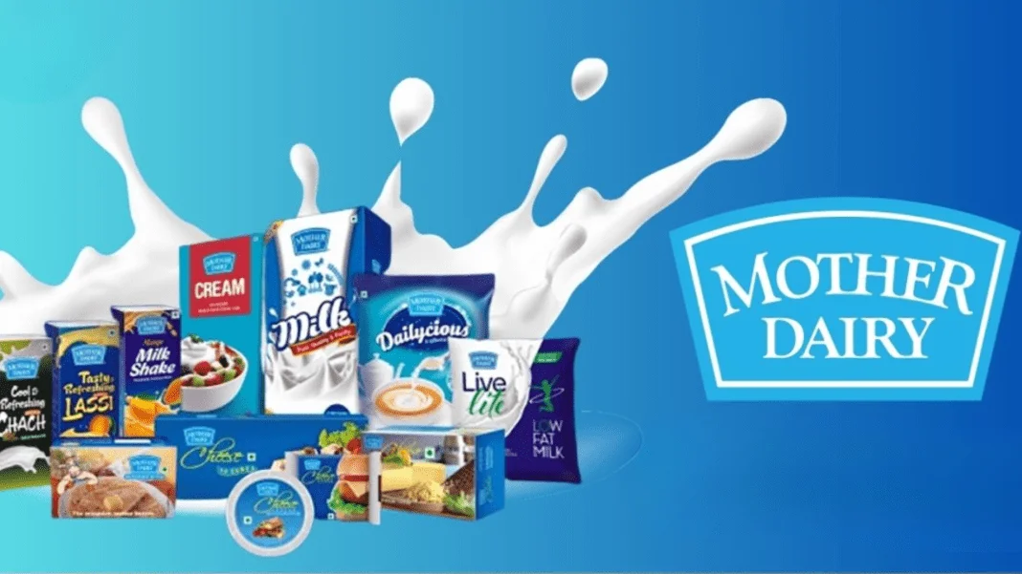

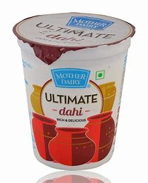 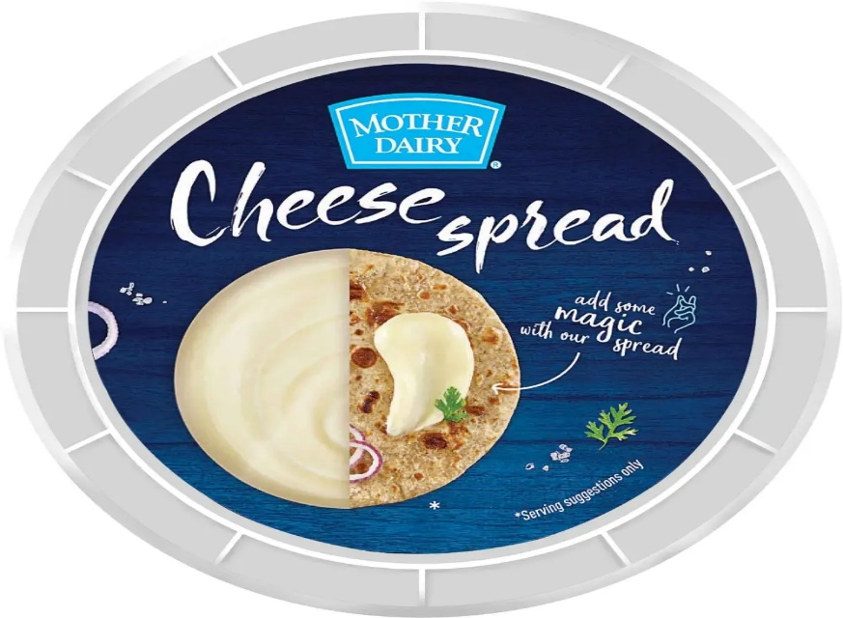

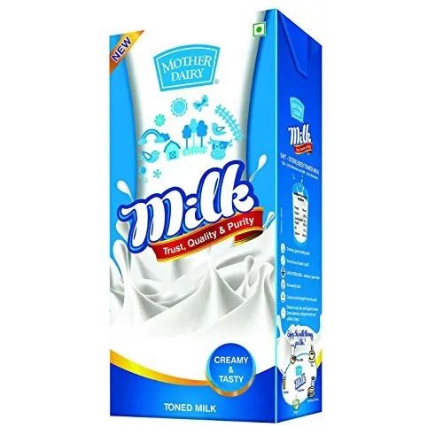

***SEO & Keyword Research***

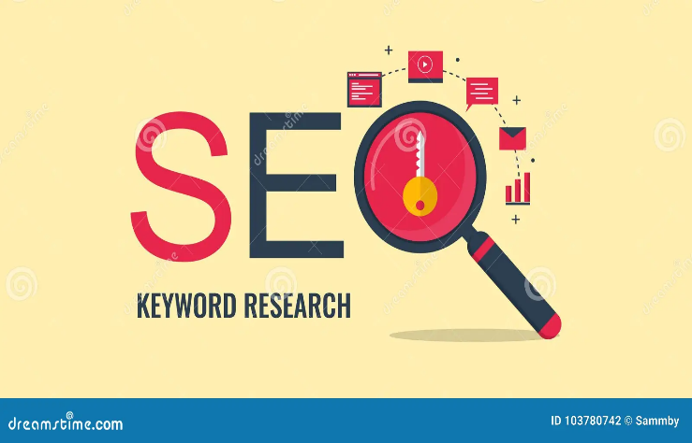

Here's an overview of the tasks involved in this milestone:

**1. SEO Audit**

**- Site Health Analysis:** Review the website for technical issues like broken links, page speed, mobile-friendliness, and crawl errors using tools such as Google Search Console or SEMrush.

**- Content Review:** Evaluate content quality, duplicate content issues, and proper use of meta tags (titles, descriptions, header tags).

**- Backlink Profile:** Analyse the quality and quantity of backlinks to ensure there are no harmful links impacting your site's authority.

**- User Experience (UX):** Assess navigation, internal linking, and overall user engagement metrics.

**2. Keyword Research**

**- Identify Target Keywords:** Use tools like Ahrefs, SEMrush, or Google Keyword Planner to find relevant keywords that match your audience's search intent.

**- Competitor Analysis:** Analyse competitors to see which keywords they are ranking for and find opportunities to outperform them.

**- Long-tail Keywords:** Focus on long-tail keywords that are less competitive but can drive highly targeted traffic.

**- Search Volume & Difficulty:** Evaluate keyword search volume, competition level, and relevance to ensure they align with your content strategy.

**3. On-page Optimization**

**- Meta Tags Optimization:** Craft compelling title tags and meta descriptions incorporating your target keywords.

**- Header Tags & Content Structure:** Use H1, H2, and H3 tags to organize your content, ensuring clarity for both search engines and users.

**- Internal Linking:** Strengthen your site architecture by linking related pages, which helps distribute page authority and improve navigation.

**- Image Optimization:** Include descriptive alt text and optimize image file sizes for faster loading times.

**- Content Quality:** Ensure that the content is informative, engaging, and aligned with the targeted keywords while avoiding keyword stuffing.

Implementing these steps should help boost your organic search visibility and improve the overall performance of the GreenEarth Organics website. If you need further details on any specific activity, feel free to ask!

***Content Ideas and Marketing Strategies:***

Here’s a structured approach to this activity:

**1. Content Ideas**

**- Educational Blog Posts:** Write about organic food benefits, sustainability tips, and healthy recipes.

**- Product Spotlights:** Highlight individual products with their benefits, sourcing details, and usage ideas.

**- User-Generated Content:** Share customer testimonials, reviews, and social media posts featuring your products.

**- Seasonal & Trend-Based Content:** Create content around organic food trends, sustainability movements, and seasonal produce.

**- Comparison & Buying Guides:** Help users choose the best organic products with detailed comparisons and buying tips.

**- Behind-the-Scenes Stories:** Share insights into your sourcing process, supplier partnerships, or company values.

**- Video Content:** Produce cooking tutorials, farm-to-table stories, and sustainability tips to engage audiences.

**2. Marketing Strategies**

**- SEO & Content Marketing:** Optimize blog posts and product pages with targeted keywords to drive organic traffic.

**- Email Marketing:** Create newsletters with personalized product recommendations, exclusive discounts, and educational content.

**- Social Media Marketing:** Engage audiences on Instagram, Facebook, and TikTok with interactive content like reels, polls, and live Q&As.

**- Influencer & Affiliate Marketing:** Partner with eco-conscious influencers and bloggers to reach a wider audience.

**- Paid Advertising:** Run Google Ads and social media ads targeting eco-friendly consumers and organic food enthusiasts.

**- Referral & Loyalty Programs:** Encourage word-of-mouth marketing by rewarding loyal customers for referrals and repeat purchases.

**- Community Engagement:** Host online workshops, webinars, or live Q&A sessions about organic living.

***Content Creation and Curation***

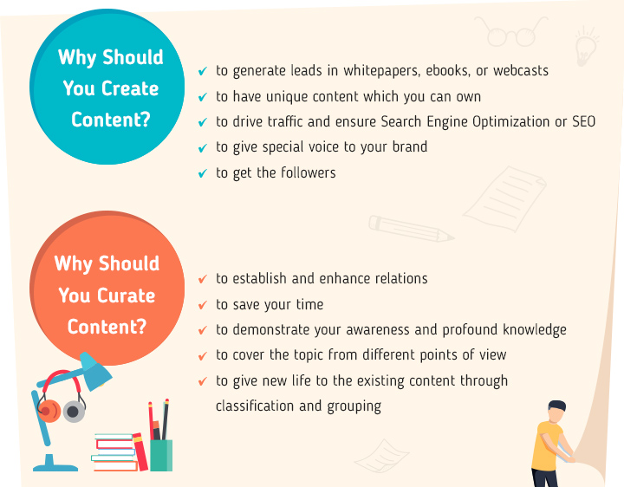

Below is a concise breakdown of the project tasks along with some guiding questions to help you develop a detailed strategy:

**1. Post Creations**

**- Objective:** Develop engaging content that resonates with your target audience.

**- Considerations:**

* Define content themes or topics.
* Create a content calendar for regular posting.
* Decide on a mix of media (images, text, videos, etc.).

**2. Designs/Video Editing**

**-** Objective: Produce visually appealing and professional designs and videos.

**- Considerations:**

* Identify the key visual style or brand guidelines.
* Choose appropriate tools/software for design and editing.
* Plan for both short-form (e.g., social media clips) and long-form content if needed.

**3. Ad Campaigns over Social Media**

**- Objective:** Execute targeted ad campaigns to increase visibility and engagement.

**- Considerations:**

* Identify which platforms (Facebook, Instagram, LinkedIn, etc.) align best with your audience.
* Define campaign objectives (e.g., lead generation, brand awareness).
* Develop ad creatives, set budgets, and establish performance metrics.

**4. Email Ideation and Creation**

**- Objective:** Craft compelling email campaigns to nurture leads and retain customers.

**- Considerations:**

* Segment your audience for personalized messaging.
* Brainstorm email topics and call-to-actions.
* Design templates and plan the email sequence (e.g., welcome series, newsletters, promotions).

***Next Steps and Questions***

**- Target Audience:** Who is your primary audience for each channel?

**- Brand Voice:** Do you have established brand guidelines or a tone that needs to be consistent across all platforms?

**- Timeline:** What are your deadlines for each component of the project?

**- Resources:** Are there any in-house tools or external agencies you plan to use for design and video editing?

